KERATAN AKHBAR
15 May2021 (Saturday)

The Star
Aidilfitri prayers | 1
New Straits Times
Malay Mail editor - in - chief dies of heart attack | 2
Nanyang Siang Pau
For those affected by MCO 3.0, Selangor allows to defer PPR rent payment | 3
"513 Cemetery" is lists as a reserved area, Tan Ah Chai: Just waiting for approval | 4
Disrepair for a long time, bad environment, Serdang Pasar has full basket of problem | 5
Teng Chang Khim said that the "Chinese dilution" remarks was improper, Ronnie Liu: Just point out that DAP is not healthy | 6
Kwong Wah Yit Poh
Its up to everyone to cut the chain of infection! | 7

KERATAN AKHBAR
15 May 2021
Akhbar | : | The Star
Tajuk Berita | : | Aidilfitri prayers
Muka Surat | : | 2

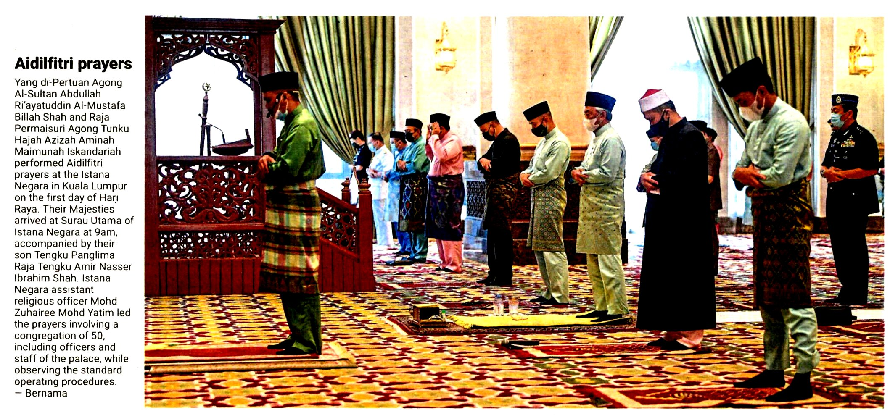
KERATAN AKHBAR
15 May 2021
Akhbar | : | New Straits Times
Tajuk Berita | : | Malay Mail editor - in - chief dies of heart attack
Muka Surat | : | 18

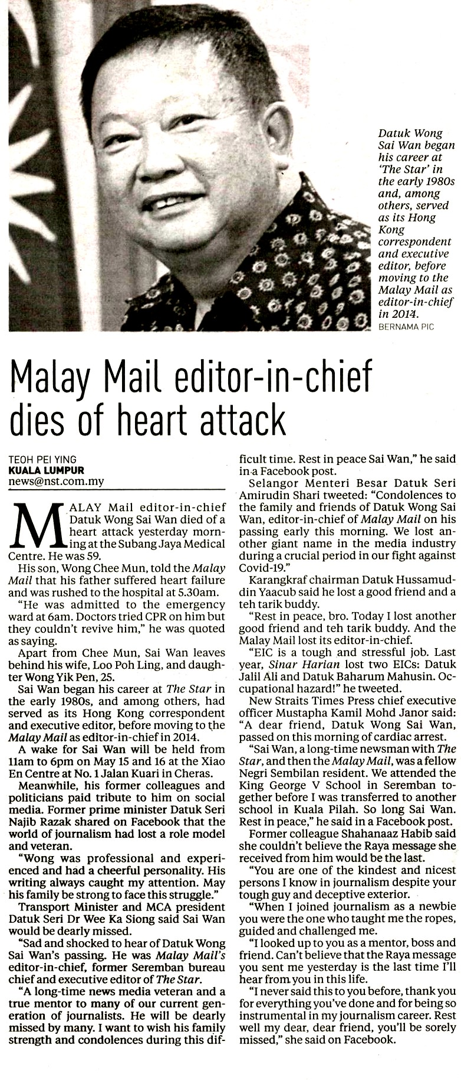
KERATAN AKHBAR
15 May 2021
Akhbar | : | Nanyang Siang Pau
Tajuk Berita | : | For those affected by MCO 3.0, Selangor allows to defer PPR rent payment
Muka Surat | : | 1

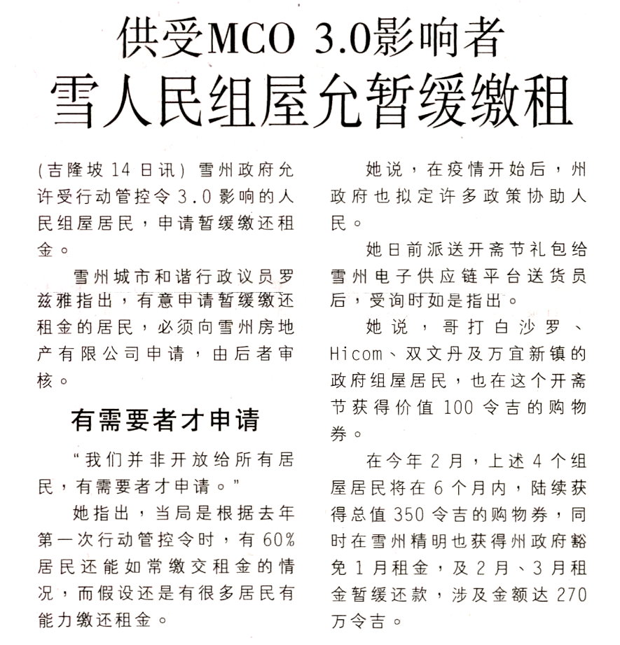
KERATAN AKHBAR
15 May 2021
Akhbar | : | Nanyang Siang Pau
Tajuk Berita | : | "513 Cemetery" is lists as a reserved area, Tan Ah Chai: Just waiting for approval
Muka Surat | : | 2

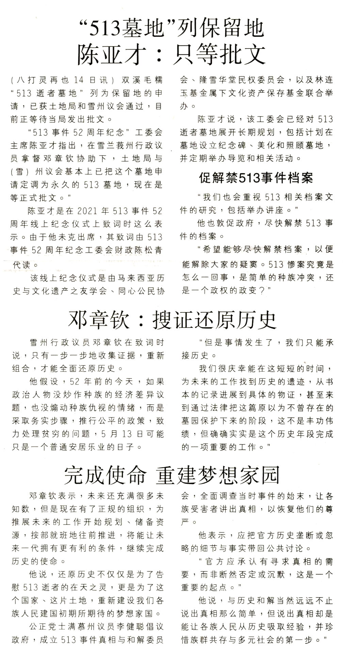
KERATAN AKHBAR
15 May 2021
Akhbar | : | Nanyang Siang Pau
Tajuk Berita | : | Disrepair for a long time, bad environment, Serdang Pasar has full basket of problem
Muka Surat | : | 8

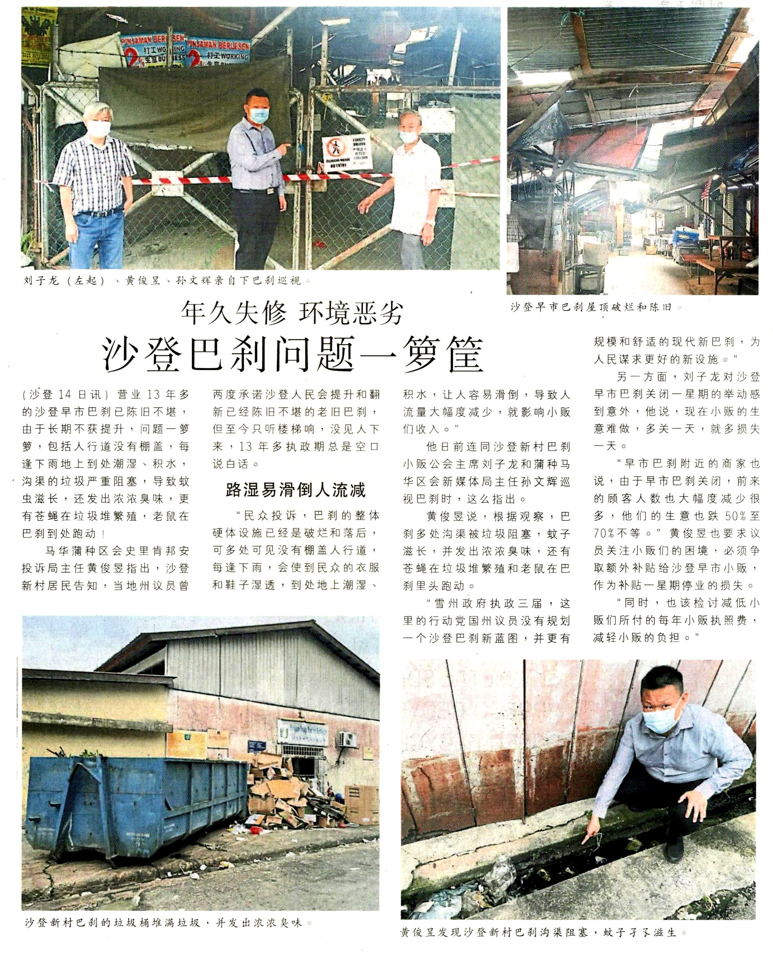
KERATAN AKHBAR
15 May 2021
Akhbar | : | Nanyang Siang Pau
Tajuk Berita | : | Teng Chang Khim said that the "Chinese dilution" remarks was improper, Ronnie Liu: Just point out that DAP is not healthy
Muka Surat | : | 16

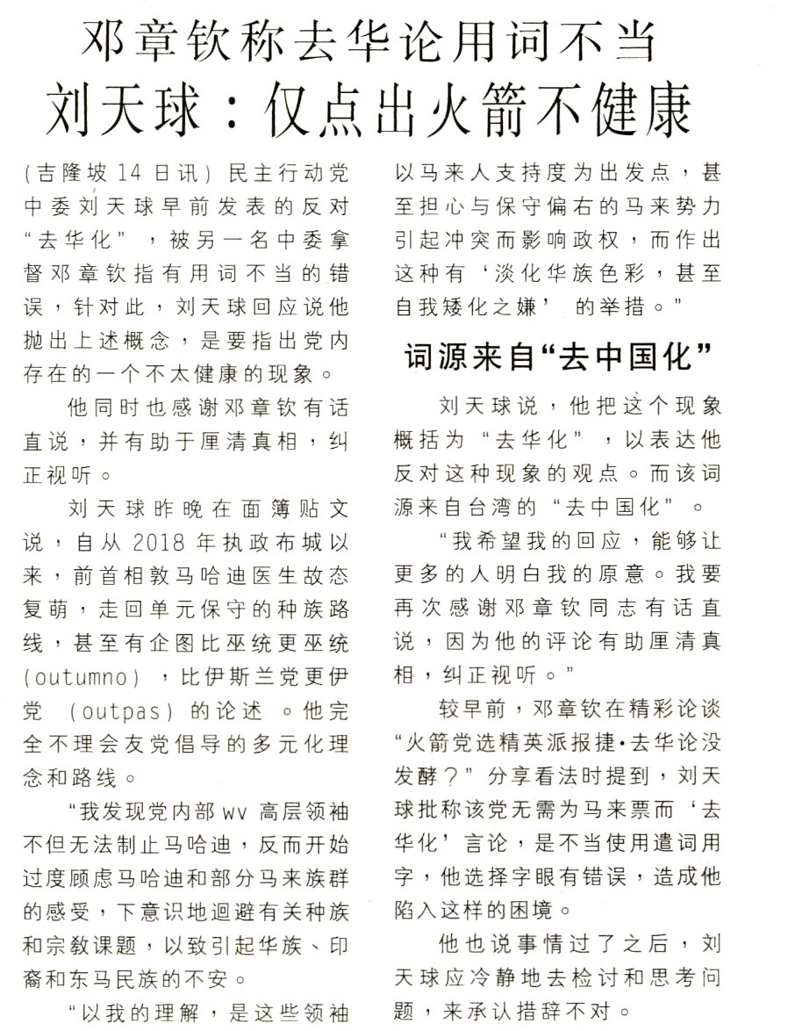
KERATAN AKHBAR
15 May 2021
Akhbar | : | Kwong Wah Yit Poh
Tajuk Berita | : | Its up to everyone to cut the chain of infection!
Muka Surat | : | 15

